
Nondispersive infrared(NDIR) Gas sensor◼
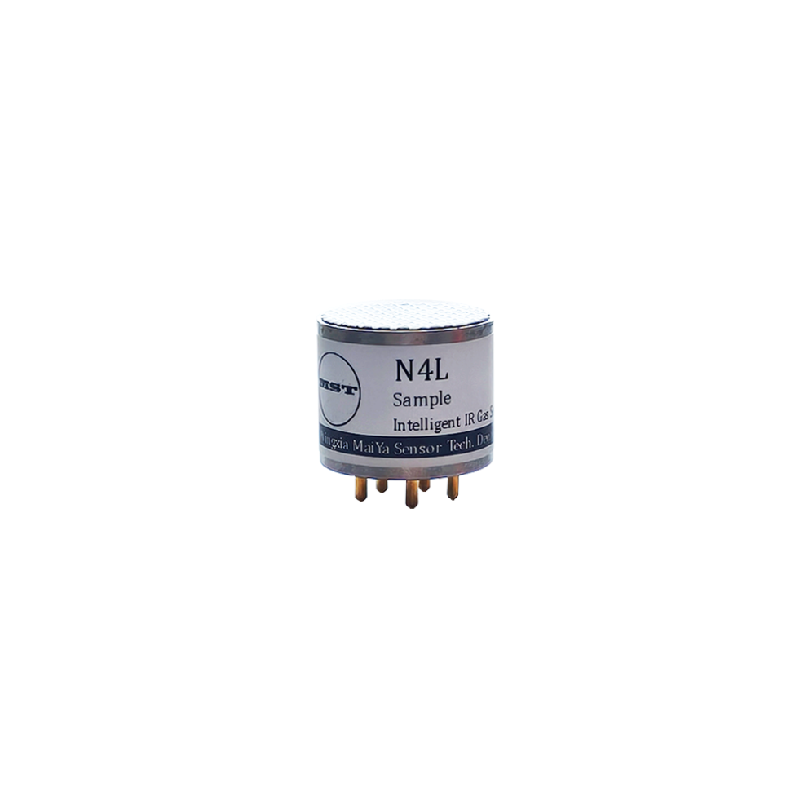
C2H4 Ethylene Sensor
MST-N4L C2H4 Datasheet
Advantages& characteristics
- Quick response and accurate measurement
- Will not get poisoned
- Working with no oxygen required
- More than 5 years lifespan
- Small size structure
Application
- Environmental detection
- Gas leakage detection
- On-line monitoring

Base Specification
◆ Detection gas | C2H4
◆ Working principle | Non-distributed infrared (NDIR)
◆ Measuring range | 0-100%LEL, 0-50%/100%vol
◆ Accuracy | ±3%FS
◆ Resolution | 1%LEL / 0.01%vol
◆ Response time (T90) | <30s (Free diffusion)
◆ Working temperature | -40℃ ~ 70℃
◆ Storage temperature | -40℃ ~ 85℃
◆ Working humidity | 0 ~ 95%RH, non-condensing
◆ Preheating time | 1min
◆ Digital output | TTL level
◆ Analog output | 0.4 ~ 2V
◆ Supply voltage | 3.0 ~ 5.5 VDC
◆ Working current | Average <60mA @ 3.3VDC
◆ Power consumption | 0.2W (Average value)
◆ Lifespan | >5 years
◆ Warranty | 1 year
◆ Weight | 21g

Pin specification
Pin mark | Function | Description
V+ | Positive electrode of power supply | 3.0 - 5.5 VDC
Gnd | Negative terminal of power supply | GND
Tx | Serial port transmitter | TTL TXD
Rx | Serial port receiver | TTL RXD
DA | Analog output | 0V means sensor failure  0.2V means sensor in preheating  0.4-2V corresponds to 0-100% F.S.  2-2.2V means overrange
Size drawing (unit: mm)
V1.0 24.7.9
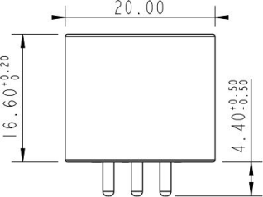
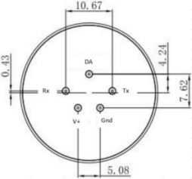
Ningxia MaiYa Sensor Technology Development Co., LTD
Address: Tower A, Yinchuan Zhongguancun Innovation Center, Helanshan Road, Yinchuan City, Ningxia, China750000.
Email: office@maiya-sensor.com,
Tel/Whatsapp: +86 18995278133, +86 18202760413
www.maiyachuangan.com, www.maiya-sensor.com

